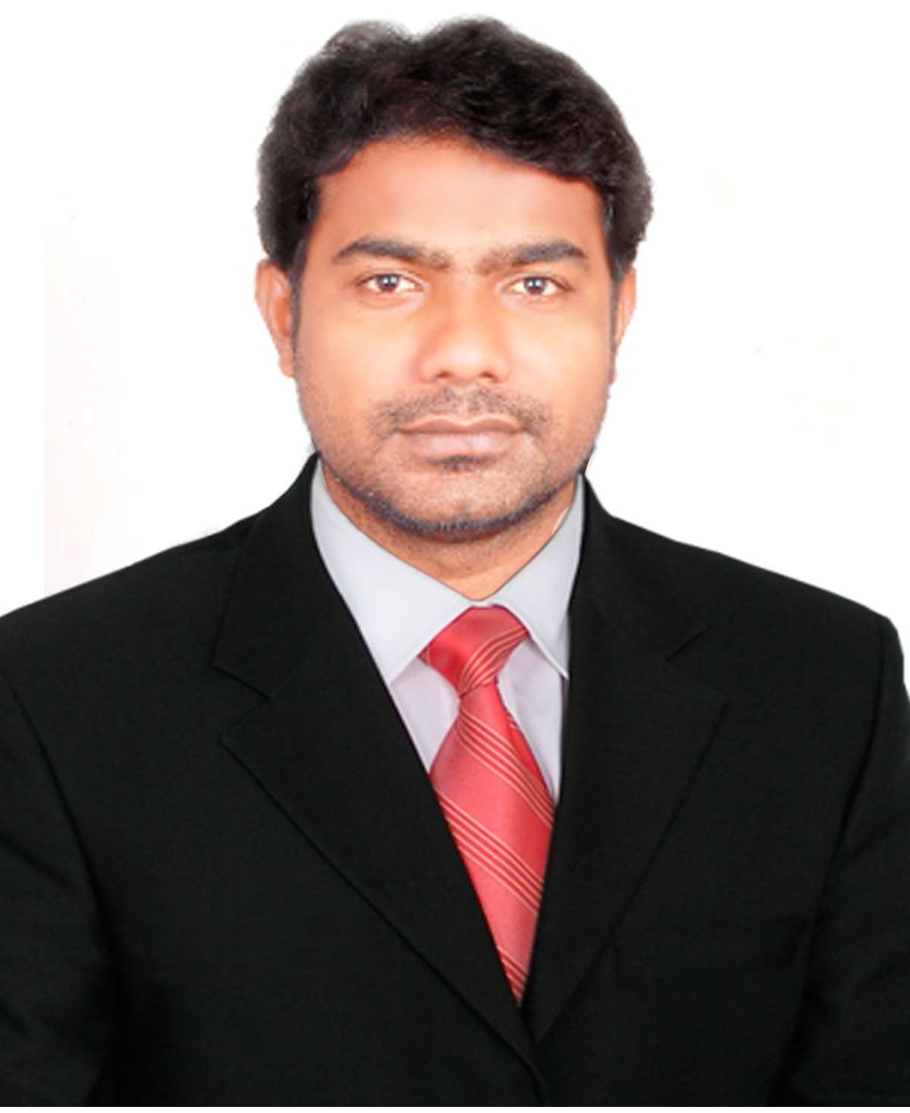
MOHD SARWAR BABU

Communication Address :Plot No : 26, Streat No : 6, Road No : 2, Brindavana Colony, Boduppal , R.R Dist ,Hyderabad- 500039, Telangana.
Permanent Address : H.No 24-1-132, Darga Kazipet, Hanamkonda Warangal -506003
 : +91-9705930993.
- : sarwarbabumcajntu11@yahoo.com

Career Objective:

To seek challenging career which enables me to bring the best out of me which offers scope for an individual towards the growth of the organization with a sense of the satisfaction while upgrading myself with the latest technology leading to a responsible position, foster my growth professionally and personally. A challenging position, utilizing abilities developed through my experience with the opportunity for professional growth based on performance.

Professional Experience:

- Working as Deputy for Principal, Technology Coordinator in New York Academy (American Curriculum) from 2018 to till date in Hyderabad.
  - Mentored teachers in curriculum development
  - Hired and supervised all support staff
  - Produced a weekly student newsletter and a multilingual monthly parent newsletter
  - Evaluated teachers based upon official observations of classroom lessons
  - Produced a 50% decline in student visits to the office for misbehavior
  - Oversaw all aspects of daily school operations
  - Planned special events including graduations
  - Managed student behavior issues and coordinated discipline plans
  - Performed fundraising, marketing and budgeting for school and summer daycare programs
  - Developed school improvement plan
  - Coordinated food service and transportation services
  - Maintained discipline during Afterschool and during the school day in principal's absence
  - Overseer of master schedule for all students, teachers, classes and lunch periods.
  - Evaluated the performance of teachers, guidance counselors, staff members, and support staff.
  - Served as principal-in-charge in the absence of the principal.
  - Instructional leader responsible for coordinating all programs and special events.

- Worked as Informatics Practices, Computer (PGT) up to 12th grade faculty and CBSE related documents In charge in VIBGYOR HIGH Group, Kallakal, Medchal, Hyderabad from 2013 to 2018. Teaching for 12th CBSE Grade Java, Netbeans, MySql, HTML, XML and for 8th to 10th MS-Office, HTML, XML, Photoshop, Flash
- Head of Department for Computer Department to appointed post holders who have responsibility for either an academic department or school. I lead, manage and develop the department to ensure it achieves the highest possible standards of excellence in all its activities. They will be supported by the PVC(Pro Vice Chancellor) Faculty, and by colleagues from within the department, Faculty, and central services.
- Created the school web site and school video animation and brochure I am very interested in all such activities. All types of CBSE reports and time table made by me. And I have responsibility in Examination Department also.
- Attending CBSE CCE and Accreditation programs.
- CBSE Coordinator.
- Attended CBSE Practical External for IP subject and CBSE paper evolutions for FIT and IP subject.
- School Web site update and maintain.
- Computer hardware maintain and networking trouble shooting
- Expert in MS Excel and MS Access, Photoshop , Web Designing.

- Worked as Computer Teacher in Ekashila Techno School , Warangal from 2011 to 2013 Feb.
- Created a school management software using MS-Access and video add for Ekashil Group of Institutions and I have responsibility in all type of reports. And teacher of the Computer Science .
- Worked as Computer Science lecture for B.Sc and B.Com students in Maharshi Degree and PG College, Warangal from 2006 to 2008,

Additional responsibilities I have held:
I am a Head of Department for Computer Department to appointed post holders who have responsibility for either an academic department or school. I lead, manage and develop the department to ensure it achieves the highest possible standards of excellence in all its activities. They will be supported by the PVC Faculty, and by colleagues from within the department, Faculty, and central services.

Extracurricular/Co scholastic activities in which I am proficient

I created the school www.tjis.in, www.tjistelangana.site40.net web sites and school video animation and broacher I very interested in these all things because I want to become professional in my subject and fulfill my dreams. All types of CBSE reports and time table made by me. And I have responsible in Examination Department also.

Achievements:

- Best performer Award from Ekashila Techno School, 2011-13
- Best IP (Computer) Teacher when I am created for Student election electronic Software 2014 in TJIS.
- Got 98/100 in Informatics practices (IP) 12th Grade of my Students 10 members.

Educational Qualifications:

Exam | Institute | Board/University | Percentage
D.El.Ed | National Institute of Open Schooling | National Institute of Open Schooling | Pursing
M.C.A | Jayamukhi Institue of technological sciences,  Narsampet, | JNTU | 75%
B.Sc  (Computer science) | New Science College  Hanamkonda, | Kakatiya University | 63%
Intermediate | Mahaboobia Inter College | Board Of Intermediate | 60%
S.S.C | St.Gabrial High School.  Kazipet. | State Board of Secondary Education | 69%
Technical Skills:
Programming Languages : C, C++, Java, HTML,CSS,Java Script,Oracle and UML.
My-SQL, Photoshop, Macromedia , XML, VB
Packages : Ms-Office.
Server Operating : MS Dos, MS Operating: 98&98, 2000,Xp, 7 & 8

Extra-curricular Activities
1. Web designing
2. Preparing video ads for schools.
3. Participated in Organizing MCA SMIGOJITS-10 and project done on online exam for
debugging.
4. Participated in NCC at state level camps in school.
5. Participated in IBM TGMC-10 for the project titled patient billing software.
6. Created student election online voting system project using JAVA first time in VIBGYOR HIGH
7. Created Online test software for the school.
8. Created School Management software in Ekashila techno school, Warangal

Strengths:

- Adaptability, flexibility, Quick learning skills.
- Optimistic, confidence, updating with computer software’s
- Hard working nature.
- Quick learning.

Personal Information :

Name : Mohd.Sarwar Babu
Fathers Name : Babu Miya
Gender : Male.
Nationality : Indian.
Marital Status : Married.
Date of Birth : 27/12/1984.
Languages Known : English, Hindi, and Telugu.
Declaration:
I here by declare that the information furnished above is true to the best of my knowledge and belief.

Place:
Date: (MOHD SARWAR BABU)

