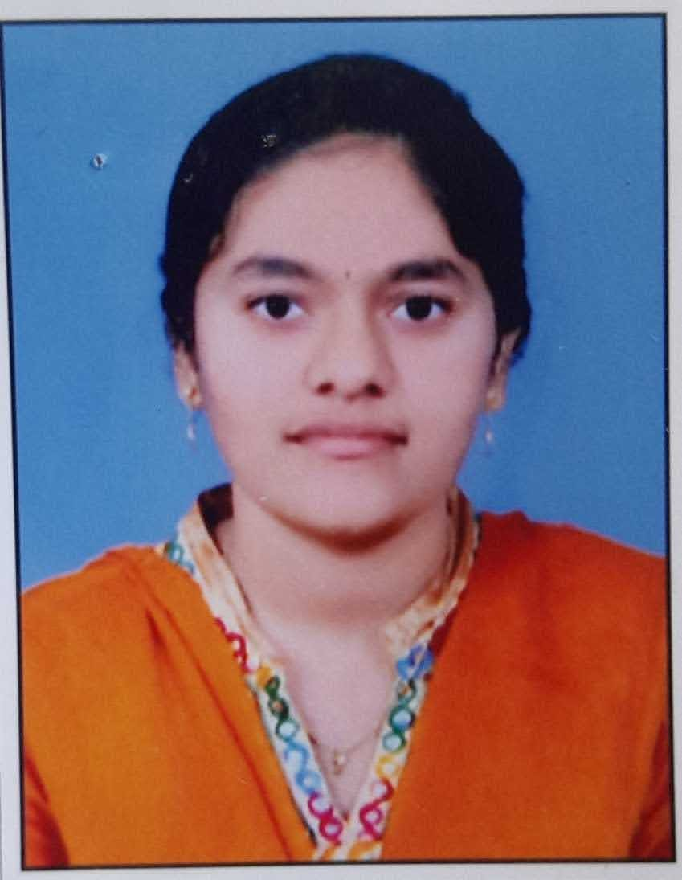
REDDYMALLA.SHRAVYA

Mail: shravyareddymalla97@gmail.com
Mobile number:9182057217
CAREER OBJECTIVE: Teaching and guiding the students of all kinds. Teaching and guiding them in all aspects. Adopting different learning strategies as per the needs of the students.
ACADEMIC PROFILE:
Course | Year of passing | Board / University | Institute | Percentage  (%)
B.Ed (Biology & Physical Sciences) | 2023 | Universiy of Mysuru | Regional Institute Of Education | -------
M.Sc ( Zoology) | 2021 | Kakatiya University | Vaagdevi Degree & P.G College | 7.74
B.sc(Bt.Z.C) | 2015-2018 | Kakatiya University | Vaagdevi Degree & P.G College | 79.8
Intermediate | 2013-2015 | Board of Intermediate Education , Telangana | S.R Junior college For Girls | 89.6
S.S.C | 2013 | Board of secondary education ,  Andhra Pradesh | Learners Land High School | 8.8

SKILLS :

- Strong communication and interpersonal skills
- Ability to motivate and engage students in learning
- Skilled in writing and executing lesson plans
- Skilled in developing innovative teaching – learning materials

STRENGTHS:
  - Dedicated towards my work
  - Hard working
  - Self motivating

EXPERIENCE:
1 .worked as student teacher in “MARIMALLAPPA‘S” & “CHINMAYA VIDYALAYA” as a part of internship programme. Successfully completed all internship work in both the schools in pedagogy of biology and physical sciences .Actively participated in curricular and co-curricular activities conducted by the school
2 .Worked as a lecturer in “PADMAVATHI DEGREE COLLEGE” for 6 months.
HOBBIES:
- Playing badminton
- Dancing
- Fine arts
PERSONAL PROFILE:
- Date of Birth : 06-10-1997
- Father’s name : Reddymalla. Swamy
- Gender : Female
- Marital Status : Single
- Nationality : Indian
- Mother tongue : Telugu
- Languages Known. : Telugu, Hindi and English
- Permanent Address : 11-23-332/3, L.B Nagar , Warangal, Telangana
.

DECLARATION :
I do here by declare that the above furnished information is true to the best of my knowledge and belief.
Place :
Date:
(R.SHRAVYA)

