

Phone : +91 6301224915

Email : [roquiyafatima1993@gmail.com](mailto:roquiyafatima1993@gmail.com)

Address: Subedari, Hanamkonda, Warangal, Telangana, India

Aspiring college professor with proven lecturing skills looking to provide students with valuable knowledge in the Zoology field. Passionate about fostering academic development and success for every student. To seek and maintain full-time position that offers professional challenges utilizing interpersonal skills, excellent time management and problem-solving skills.

|  |  |  |  |
| --- | --- | --- | --- |
|  |  |  |  |
| Bachelor of Education | Kakatiya University | 6.7 | 2018 - 2020 |
| Master's Degree - MSc Zoology | Kakatiya University | 73% | 2013 - 2015 |
| Bachelor's Degree - BSc Zoology & Chemistry | Kakatiya University | 65% | 2010 - 2013 |

Adaptability Microsoft Ofﬁce Class management Online lectures

Student records management Learning Management Systems Curriculum Development Presentations

**Working as Post graduate teacher** at St Peter’s central public school

July 2021 - June 2024



Vaagdevi Degree and PG College

* Used variety of learning modalities and support materials to facilitate learning process and accentuate presentations.
* Evaluated and revised lesson plans and course content to achieve student-centered learning. Created and designed quizzes, tests and projects to assess student knowledge.
* Collaborated with faculty and staff to create meaningful learning experiences.
* Selected and designed lesson plans and curriculum to meet academic objectives. Implemented instructional technologies in course delivery to engage and educate students.
* Arranged syllabus, developed schedule, and determined reading list for varied courses
* Simultaneously, giving students appropriate time to complete assignments and absorb information. Built strong rapport with students through class discussions and academic advisement.

July 2017 - June 2020

Pingle Degree & PG College for Women

* Encouraged class discussions by building discussions into lessons, actively soliciting input, asking open-ended questions and using techniques to track student participation.
* Shifted between informal and formal methods of teaching to create multi-layered web of learning Incorporating experiments, practical activities, discussions, and projects into lessons.
* Researched and selected course texts and supplemental learning materials.
* Graded tests and assignments and uploaded to school database
* Supported multidisciplinary research teams focused on scholarly publication. Conducted on-going program assessment, enrollment and retention tracking.
* Identiﬁed research opportunities for students, assisting with gathering data and drawing conclusions for projects.
* TS TET Qualiﬁed
* C TET Qualiﬁed
* TREIRB Qualiﬁed
* TSPSC Group 4 Qualiﬁed

Reading

Travelling

English Urdu Hindi Telugu

I hereby declare that all the information furnished in my resume is true and correct to the best of my knowledge and belief.

Date:

Place:

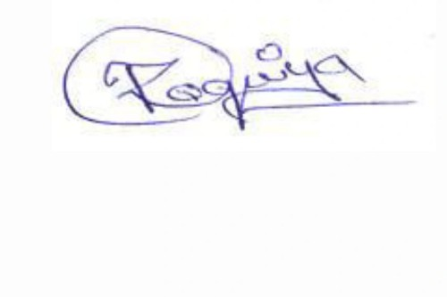

ROQUIYA FATIMA