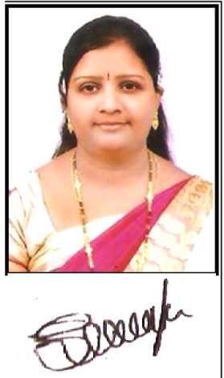 **✆+91 9885258558 / 9848048895**

**🖂: swapnakiran1983@gmail.com**

**SWAPNA SAMUDRALA**

**Mission Statement:**

**Personal Profile:**

D/O :

Smt. Akhila

Late Agaiah

**Married to :**

S. Kiran Kumar

**Blessed with :**

Abinav

Keerthan

**Date of Birth:**

30th April, 1983

**Nationality :**

Indian

**Hobbies :**

Reading Books

Singing Songs

**Permanent Address:**

# 3-4-80/2

Sudhanagar

Hanamkonda

Dist. Warangal Urban

Telangana 506 001.

* To emerge as a role model in holistic, value based and exploratory environment, to be an ever learner & to be a participative contributor to the society through a vision centric organization.

**Profile:**

* A self driven, results oriented with a positive outlook a natural forward planner in administration and academic research. Mature, Credible and comfortable in dealing with all the domains of administration. Reliable, tolerant, determined and a good team player. A well presented, professional and flexible for assignments / participations / counseling.

**Work Experience:**

* 5 Years of **High School Telugu Teacher & Coordinator** in **DELHI PUBLIC SCHOOL,** Warangal. (2015-2020)
* 4 Years of **High School Telugu Teacher** in **Pathfinder High School,** Hanamkonda. (2010-2014)
* 3 Years of **High School Telugu Teacher & Co-ordinator** in **Gurudath Talent High School,** Hanamkonda. (2008-2010)
* 2 Years of **Part time Lecturer in Telugu Mathrusri Degree College for Women,** Hanamkonda.

**Strength:**

* Passionate and thirsty to learn things.
* Understand the role as well as responsibility of the chair, in time action plan to meet the organizational goals.
* Obedient, Straight forward, transparent in action & a team motivator.
* Inculcates ownership and never takes the advantages of position.

**Academic Profile:**

* **B.Ed (Methods Telugu & Social)** from Sravanthi College of Education, Dharmaram, Warangal District (Distinction)
* **M.A. (Telugu)** from Dr. B.R Ambedkar Open University, Warangal.
* **M.A. (Sociology)** from Kakatiya University, Warangal.
* **B.A. (SPP)** from Kakatiya University, Warangal.
* **Intermediate (BPC)** from St. Joseph Jr. College, Hanamkonda, Dist. Warangal.
* **SSC** from Samatha High School, Hanamknda, Dist. Warangal.
* **AP TET** Qualified from APTET, Hyderabad

**Languages Known:**

* Telugu + + +
* English + + +

**Computer Skills:**

* MS word, Excel, Internet Browsing
* Telugu Typing
* Preparation of Handbook Question Papers
* Worksheets
* Projects

**Professional Life Cycle:**

* There is always a scope for development

WORK

PERSIST IMPROVE

IDEAS FOCUS

SERVE PASSION

PUSH

**(SWAPNA SAMUDRALA)**