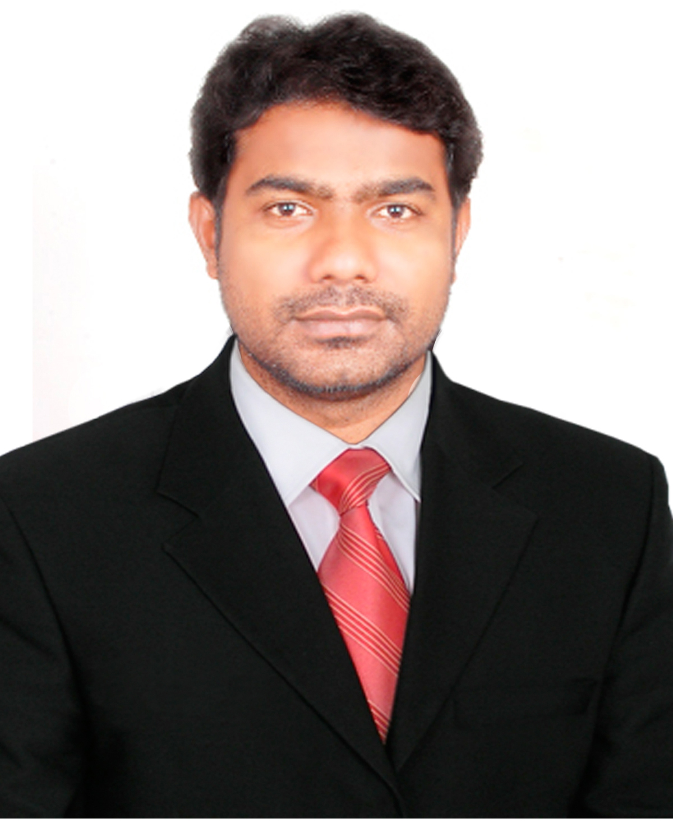**MOHD SARWAR BABU**

H.No 24-1-132, Darga Kazipet, Hanamkonda,

Warangal Telangana.

☎ **:** +91-9705930993.

* **:** sarwarbabumcajntu11@yahoo.com

**Career Objective:**

Very enthusiastic Computer Science Teacher who is technically certified in several operating system platforms. Adept at developing interactive lesson plans maintaining a safe and clean lab and helping students with specialised projects. Specialises in getting students to understand the practical side of computers and teaching students Internet responsibility.

**Highlights :**

* Excellent networking and computer support skills
* Exceptional ability to make meaningful contact with students and parents
* Very strong presentation abilities
* Always looking for new ways to create meaningful lesson plans

**Professional Experience 12 year Exp:**

**Web Artic Trainer & Online Computer Science Trainer 2019 to till date**

**AUPP (Australia Unified Pathway Program) Warangal Branch, Telangana**

Working as Computer Science Trainer Web Artic (Web design, Web Development, Front End and Back End) PHP, JavaScript, MySQL,CSS Developer . This course belongs to Abroad study one year in India and two year Australia. The AUPP programs have been developed in conjunction with ATMC and the programs utilize ATMC curriculums under license. AUPP provides its specially crafted Credit Transfer Program to obtain an ATMC Diploma Advance Information Technology qualification before admission to the Federation University at ATMC’s Sydney/Melbourne campus for completing the relevant undergraduate degrees.

* Manage digital design projects and work closely with clients to manage expectations, team roles, and the status of projects
* Develop for users with disabilities and assisted technology
* Make recommendations for Website improvements based on findings from site statistics
* Work with project stakeholders to develop mockups and translate them to HTML/CSS user interfaces
* Manage website infrastructure through business-imposed maintenance periods, outages and corporate network infrastructure upgrades
* Work closely with back-end developers to seamlessly hand off front-end code
* Develop responsive pages and templates for use in a Wordpress development environment

**Technology Coordinator & Computer Science Lecture 2016 to 08-09-2019**

**New York Academy Jubilee Hills, Hyderabad**

Worked as Computer Science Head, IT Manager and Educational Technology Coordinator in New York Academy (American Curriculum) from 2016 to till date in Hyderabad and evaluates the integration of educational technology as tools to support instruction. Serve as sole technology coordinator and manage all technology for school with 40 staff members and 450 students. Manage installation, troubleshooting, maintenance, and technical support for 100 Mac computers and iPads. Provide direct, instructional support and guidance to teachers on integrating technology within classrooms. Research, evaluate, identify, and recommend new technologies to serve as learning tools for students. Identify best practices for technology integration, trends, and applications related to technology use in the school program. Responsible for asset management and year-end inventory. Direct training sessions on technology usage for teachers.

* Recommended and led implementation of 50 iPads into curriculum.
* Responsible for developing interactive and interesting lesson plans based on approved curriculum.
* Responsible for a passing rate of 90 percent.
* Responsible for creating several after school computer labs that helped students understand how to properly use the Internet.
* Apple Administrator macOS 13.0 certified trainer.
* Led after-school computer club comprised of 25 students and taught them how to create wiki pages, online posters using Glogster, and PowerPoint presentations. Aligned club initiatives with class lesson plans.
* Facilitated school's transition of emails to Google accounts by training 80 staff members on use of new technology.
* Introduced and setup Google Classroom in curriculum.
* Staff development programs in technology.
* Coordinated and supervised the selection, purchase, and maintenance of instructional technology materials and equipment.
* Trained teachers/users at all levels on how to more effectively use PowerSchool.
* IT building support - Provided Windows and Mac desktop support to all teachers and staff.
* Web manager - Created school site using Google Docs and HTML.
* Video/still photographer - Photographed school events along with video documentaries.

**Head of Department for Computer Science 2013 to 2016**

**VIBGYORE HIGH Group Kallakal, Hyderabad**

Worked as Informatics Practices, Computer (PGT) up to 12th grade faculty and CBSE related documents In charge in **VIBGYOR HIGH Group**, Kallakal, Medchal, Hyderabad from 2013 to 2016. Teaching for 12th CBSE Grade Java, Netbeans, MySql, HTML, XML and for 8th to 10th MS-Office, HTML, XML, Photoshop, Flash

* Head of Department for Computer Department to appointed post holders who have responsibility for either an academic department or school. I lead, manage and develop the department to ensure it achieves the highest possible standards of excellence in all its activities. They will be supported by the PVC(Pro Vice Chancellor) Faculty, and by colleagues from within the department, Faculty, and central services.
* Created the school web site and school video animation and brochure I am very interested in all such activities. All types of CBSE reports and time table made by me. And I have responsibility in Examination Department also.
* Attending CBSE CCE and Accreditation programs.
* CBSE Coordinator.
* Attended CBSE Practical External for IP subject and CBSE paper evolutions for FIT and IP subject.
* School Web site update and maintain.
* Computer hardware maintain and networking trouble shooting
* Expert in MS Excel and MS Access, Photoshop , Web Designing.

**Computer Science Teacher 2011 to 2013**

**Ekashila Techno School, Warangal**

Worked as **Computer Teacher** in **Ekashila Techno School** , Warangal from 2011 to 2013 Feb.

* Created a school management software using MS-Access and video add for Ekashil Group of Institutions and I have responsibility in all type of reports. And teacher of the Computer Science .

Worked as Computer Science lecture for B.Sc and B.Com students in **Maharshi Degree and PG College**, Warangal from 2006 to 2008,

**Additional responsibilities I have held:**

I am a Head of Department for Computer Department to appointed post holders who have responsibility for either an academic department or school. I lead, manage and develop the department to ensure it achieves the highest possible standards of excellence in all its activities. They will be supported by the PVC Faculty, and by colleagues from within the department, Faculty, and central services.

**Extracurricular/Co scholastic activities in which I am proficient**

I created the school [www.tjis.in](http://www.tjis.in), www.tjistelangana.site40.net web sites and school video animation and broacher I very interested in these all things because I want to become professional in my subject and fulfill my dreams. All types of CBSE reports and time table made by me. And I have responsible in Examination Department also.

**Achievements:**

* Best performer Award from Ekashila Techno School, 2011-13
* Best IP (Computer) Teacher when I am created for Student election electronic Software 2014 in TJIS.
* Got **98/100 in Informatics practices (IP) 12th Grade** of my Students 10 members.
* Expert in Google Classroom and GSuite setup

**Educational Qualifications:**

|  |  |  |  |
| --- | --- | --- | --- |
| **Exam** | **Institute** | **Board/University** | **Percentage** |
| D.El.Ed | National Institute of Open Schooling | National Institute of Open Schooling | Pursing |
| M.C.A | Jayamukhi Institue of technological sciences,  Narsampet, | JNTU | 75% |
| B.Sc  (Computer science) | New Science College  Hanamkonda, | Kakatiya University | 63% |
| Intermediate | Mahaboobia Inter College | Board Of Intermediate | 60% |
| S.S.C | St.Gabrial High School.  Kazipet. | State Board of Secondary Education | 69% |

**Technical Skills:**

ProgrammingLanguages  **: C, C++, Java, Python HTML,CSS,Java Script,Oracle and UML, Webdesign, My-SQL, Photoshop, Macromedia , XML, VB**

Packages  **: Ms-Office.**

Server Operating **: MS Dos, MS Operating: 98&98, 2000,Xp, 7 & 8**

**Extra-curricular Activities**

1. Web designing

2. Making video ads for schools.

3. Participated in Organizing MCA **SMIGOJITS-10** and project done on online exam for

debugging.

4. Participated in NCC at state level camps in school.

5. Participated in IBM TGMC-10 for the project titled patient billing software.

6. Created student election online voting system project using JAVA first time in VIBGYOR HIGH

7. Created Online test software for the school.

8. Created School Management software in Ekashila techno school, Warangal

**Strengths:**

1. Adaptability, flexibility, Quick learning skills.

2. Optimistic, confidence, updating with computer software’s

3. Hard working nature.

4. Quick learning.

**Personal Information :**

**Name**   **:** Mohd.Sarwar Babu

**Fathers Name :** Babu Miya

**Gender :** Male.

**Nationality :** Indian.

**Marital Status  :** Single.

**Date of Birth    :** 27/12/1984.

**Languages Known  :**English, Hindi, and Telugu.

**Declaration:**

I here by declare that the information furnished above is true to the best of my knowledge and belief.

Place:

Date: (**MOHD SARWAR BABU**)