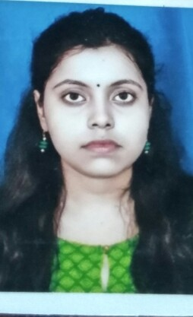
RESUME
PERSONAL DETAILS
Name- Suparna Das
Father's Name- Subhas Das
Age-26years
Sex -female
Address- New central mill Co LTD Albion lake view Budge Budge ; kolkata 700137
Email- creativesuparna@gmail.com
Ph no-9038109628

QUALIFICATIONS
Passed out ICSE examinations in the year 2009 from Ram Mohan Missions High School
Passed out WBCHS examinations in the year 2011 from Kalipur High School
Passed out honours Graduate (B.SC) in the year 2014 with 1st class marks.
M.Sc in environmental science from Vidya Sagar University in the year 2019 and B.ed from Rayeelseema University.

SKILLS
Have good fluency in English and have basic computer knowledge.

WORK EXPERIENCE
Worked 3years in Teresa Day school as a science teacher from 2014-2017
1 year in El bethel school as a biology teacher from 2017-2018
2year in Birla open minds international school 2018-2020
Currently working in International Delhi public school 2020
RECENT Allowance
32000/-month
Notice period- 1 month

INTERESTED IN OR HOBBIES
music,painting.
Achievements
I have worked as a bio science laboratory teacher for grade 11 and 12,and also helped students for science Olympiad as a result I got an appreciation certificate from the board.

Goals
To give free education to the underprivileged children.

Contributions
I will try to make the subject more interesting by various activities so that students will get keen interest to know it more. And along with that I will try to uplift their moral values.

Thanking you;
Suparna Das
Place- Andhra Pradesh

